🧪 🖥️ LAB: Shell Scripting for Log Monitoring
🎯 Goal
You will:
- Write a script
- Automate log checking
- Detect errors automatically
👉 This is real-world DevOps work

⚙️ Step 1: Create a sample log file
nano app.log
Paste:
INFO: Application started
ERROR: Database failed
INFO: User login
WARNING: Disk space low
ERROR: Timeout occurred
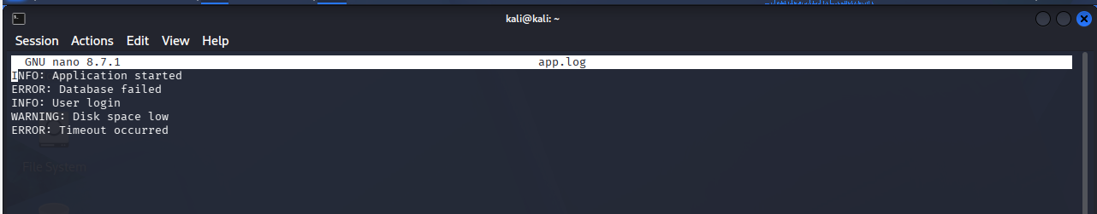

🧾 Step 2: Create a shell script
nano monitor.sh

✍️ Step 3: Write script
Paste this:
#!/bin/bash
echo "🔍 Checking logs for errors..."
count=$(grep -c "ERROR" app.log)
echo "Total ERROR count: $count"
if [ $count -gt 0 ]
then
echo "⚠️ Errors found! Please check logs."
else
echo "✅ No errors found."
fi
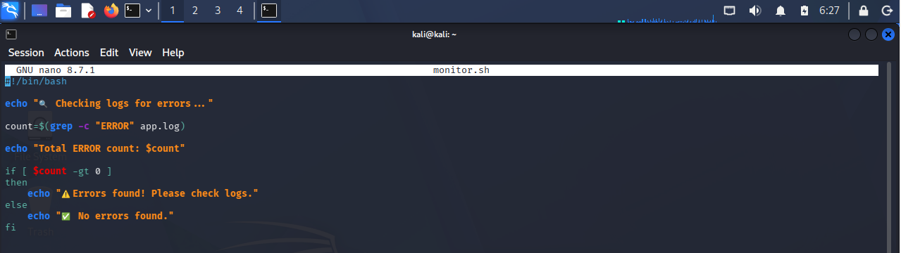

🔐 Step 4: Give permission
chmod +x monitor.sh
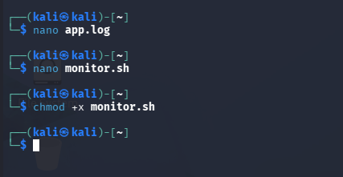

▶️ Step 5: Run the script
./monitor.sh
🎯 Expected Output
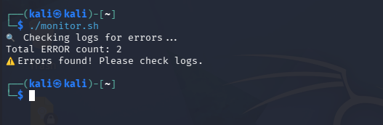

🔥 Step 6: Improve script (Real-world version)
Update script:
#!/bin/bash
LOG_FILE="app.log"
echo "🔍 Monitoring $LOG_FILE..."
if [ ! -f $LOG_FILE ]; then
echo "❌ Log file not found!"
exit 1
fi
errors=$(grep -i "error" $LOG_FILE | wc -l)
echo "Error count: $errors"
if [ $errors -gt 0 ]; then
echo "🚨 ALERT: Errors detected!"
else
echo "✅ System healthy"
fi
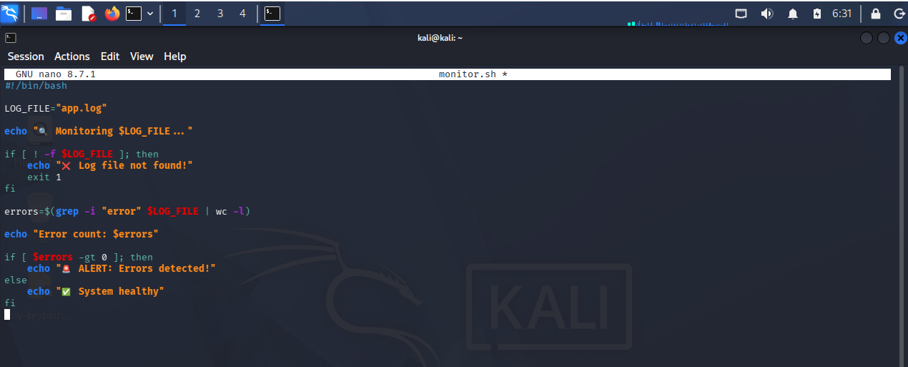

🚀 Step 7: Automate (Optional)
Run every minute:
crontab -e
Add:
* * * * * /path/to/monitor.sh
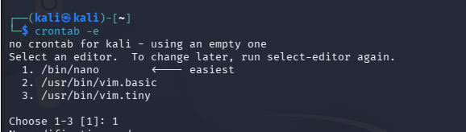
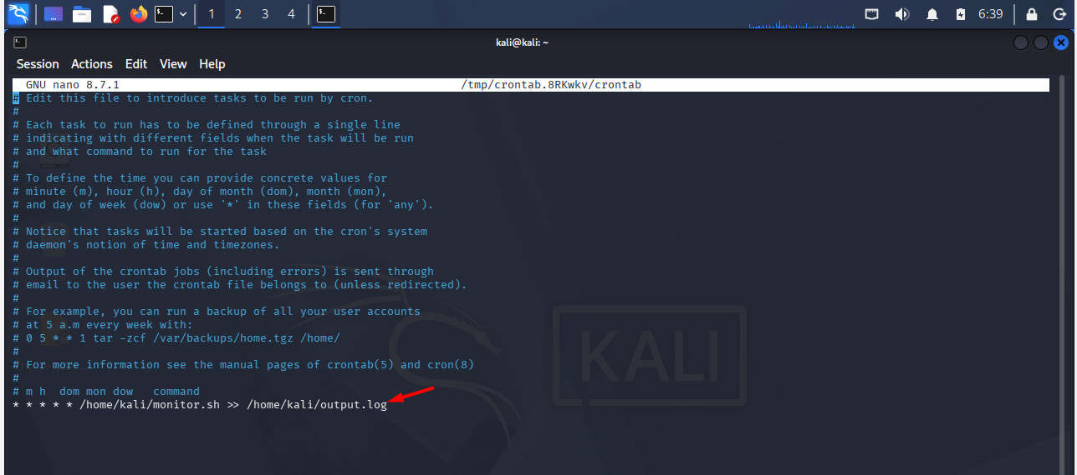

Checking the output.log
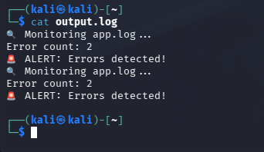

🧠 What you learned
- Writing shell scripts
- Automating tasks
- Using variables
- Conditional logic
- Error handling

🎤 Interview answer
“I created a shell script to monitor logs, count errors, and generate alerts. I also added validation and automation using cron.”

💡 Real-world usage
- Log monitoring
- Health checks
- Automation
- Alerting

